Visuals for customer churn:

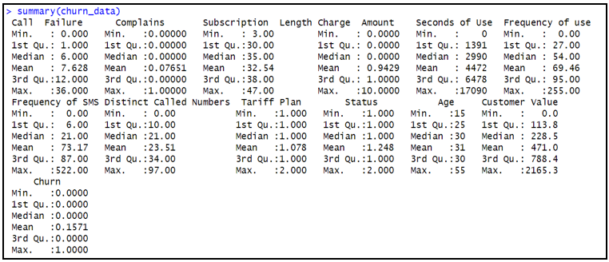

**Figure 1 Dataset Summary**

**Figure 2 Correlation matrix and analysis**

**Figure 3 Confusion matrix for best model (Random Forest)**

**Figure 4 Accuracy comparison table**